Secure Networks with Firewalls NAT Port Filtering, Packet Filtering And Other Methods :
Tasks :
1.
Set up Windows Defender Firewall on your Windows laptop or PC and create a new inbound rule to block all incoming traffic on port 8080. Take a screenshot of the rule you created.
ANS :

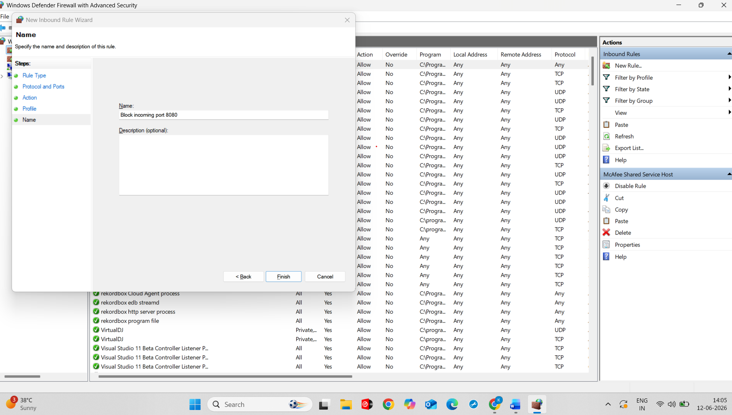
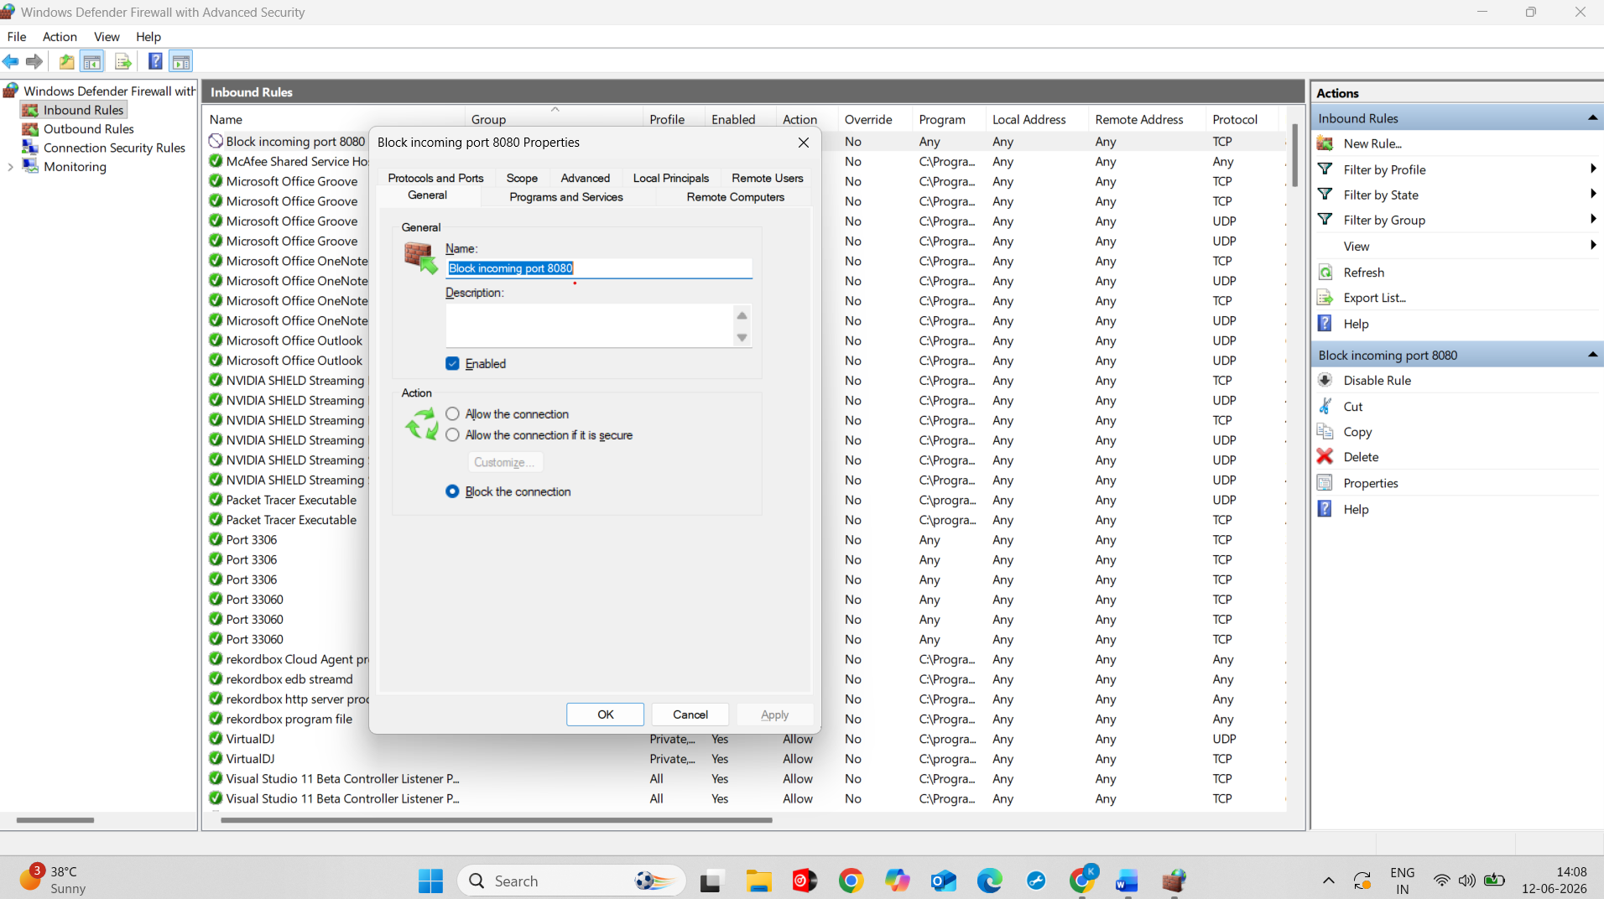
2.
Simulate NAT (Network Address Translation) by drawing a simple diagram showing how your home WiFi router assigns private IP addresses to your phone, laptop, and smart TV, and how it translates them to a single public IP for internet access. <br> <br> <em> <strong> Hint: </strong> Use any drawing tool or even hand-draw and click a photo. </em>
ANS :
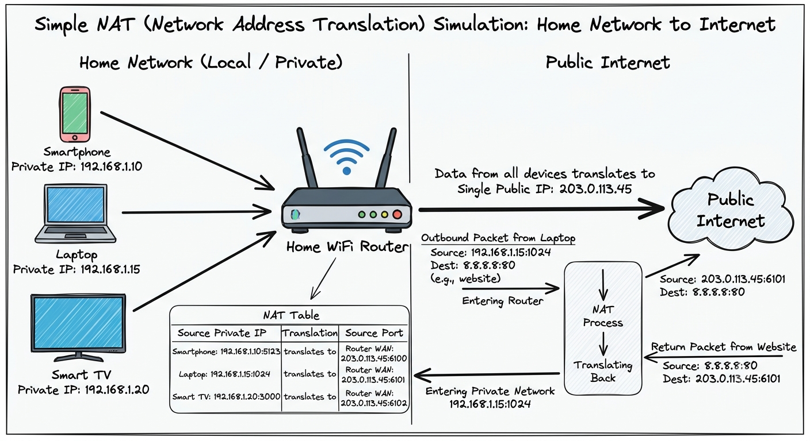
3.
Configure port filtering using your WiFi router's admin panel (or use a router simulator online if you don't have access). Block outgoing traffic on port 25 (SMTP) and explain in 2 sentences how this could help prevent spam from your network.
ANS :
Port Filtering Configuration :
Setting | Value
Rule Name | Block SMTP
Direction | Outbound
Protocol | TCP
Port Number | 25
Action | Deny/Block
Status | Enabled

Steps Performed
- Opened the router administration panel (simulated environment).
- Navigated to Security → Port Filtering.
- Created a new outbound filtering rule.
- Selected TCP protocol and specified port 25 (SMTP).
- Set the action to Block/Deny.
- Saved and applied the configuration.

Explanation (2 Sentences)
Blocking outgoing traffic on port 25 prevents unauthorized devices or malware from sending email directly through SMTP servers. This helps reduce spam originating from the network and protects the network frombeing blacklisted.

4.
Given a sample packet filtering rule set (provided by your trainer), identify which of these three sample packets would be allowed or blocked: 1) HTTP request from 192.168.1.5 to 172.217.166.78:80, 2) SSH request from 10.0.0.10 to 34.201.23.1:22, 3) DNS query from 192.168.1.7 to 8.8.8.8:53.<br><br><em><strong>Hint:</strong> Focus on source/destination IPs and ports in the rule set.</em>
ANS :
Packet Filtering Rules
Rule | Protocol | Port | Action
1 | HTTP | 80 | Allow
2 | HTTPS | 443 | Allow
3 | DNS | 53 | Allow
4 | SSH | 22 | Block

Packet Analysis

Packet | Source IP | Destination IP | Port | Result | Reason
HTTP request | 192.168.1.5 | 172.217.166.78 | 80 | Allowed | HTTP traffic on port 80 is permitted.
SSH request | 10.0.0.10 | 34.201.23.1 | 22 | Blocked | SSH traffic on port 22 is blocked by the rule set.
DNS query | 192.168.1.7 | 8.8.8.8 | 53 | Allowed | DNS traffic on port 53 is allowed for name resolution.

1. HTTP request from 192.168.1.5 to 172.217.166.78:80 → Allowed
2. SSH request from 10.0.0.10 to 34.201.23.1:22 → Blocked
3. DNS query from 192.168.1.7 to 8.8.8.8:53 → Allowed

5.
Research and list 3 ways Instagram or Zomato might use firewalls and packet filtering to protect their servers from attacks or misuse.
ANS :
1. Block Unauthorized Access
- Firewalls allow only approved traffic to reach servers.
- For example, Instagram may allow web traffic on ports 80 (HTTP) and 443 (HTTPS) while blocking unnecessary ports.
- This reduces the risk of hackers gaining access through unused services.
2. Prevent DDoS and Malicious Traffic
- Packet filtering can identify and block suspicious packets coming from unknown or blacklisted IP addresses.
- If attackers send a huge number of requests to overwhelm servers (DDoS attack), the firewall can filter or rate-limit that traffic.
- This helps keep Instagram or Zomato available to legitimate users.
3. Restrict Access to Internal Systems
- Firewalls separate public-facing servers from internal databases and administrative systems.
- Only specific servers and employees are allowed to access sensitive resources.
- This prevents attackers from directly reaching customer data even if a public server is compromised.
Conclusion
Instagram and Zomato use firewalls and packet filtering to:
- Block unauthorized access to servers.
- Detect and filter malicious or excessive traffic.
- Protect internal systems and customer data through controlled network access.
These security measures help maintain service availability, protect user information, and reduce the risk of cyberattacks.

